**VISION DOCUMENT**

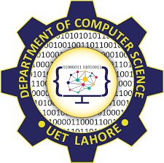

**Session 2023-2027**

**Submitted by:**

Sumaira Hafeez 2023-CS-01

**Supervised by:**

Sir Awais Hassan

**Course:**

CSC-102 Programming Fundamentals

Department of Computer Science

**University of Engineering and Technology**

**Lahore Pakistan**

**Vision of 1st Year**

**Business Application**

I want to develop an Application for

Mess management system where the users are the Mess manager and the hostel residents. This application will allow the mess manager to manage all the records of the available stock, number of students and their daily check and balance. It will also provide information about how much total bill of each student is being made. On the student end, the application provides them interface to decide on the menu and take days off. The application will automatically add the students total bill and will also display them their bill on daily basis.

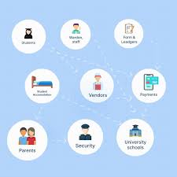

**2D GAME:**

I want to develop a game named Fly High in it there is a fighter jet that has to drop bomb on some targets on the ground. If the bomb falls anywhere else other than the Target it's points will be deducted furthermore there is also an enemy tanker on the ground from whose shooting he has to keep himself safe BECAUSE it's shot will destroy the plane and end the game. There is also an enemy that is in air and chasing the plane and another enemy that is shooting the plane he has to keep himself safe from this plane.

